**Decision Trees**

Decision tree is a type of supervised learning algorithm (having a pre-defined target variable) that is mostly used in classification problems. It works for both categorical and continuous input and output variables

Decision tree builds classification or regression models in the form of a tree structure. It breaks down a dataset into smaller subsets with increase in depth of tree. The final result is a tree with **decision nodes** and **leaf nodes**.

**Types of Decision Trees**

Types of decision tree is based on the type of target variable we have. It can be of two types:

1. **Categorical Variable Decision Tree:**Decision Tree which has categorical target variable then it called as categorical variable decision tree. Example “Student will play cricket or not” i.e. YES or NO.
2. **Continuous Variable Decision Tree:**Decision Tree has continuous target variable then it is called as Continuous Variable Decision Tree.

**Important Terminology related to Decision Trees**

Let’s look at the basic terminology used with Decision trees:

1. **Root Node:**It represents entire population or sample and this further gets divided into two or more homogeneous sets.
2. **Splitting:**It is a process of dividing a node into two or more sub-nodes.
3. **Decision Node:**When a sub-node splits into further sub-nodes, then it is called decision node.
4. **Leaf/ Terminal Node:**Nodes do not split is called Leaf or Terminal node.

[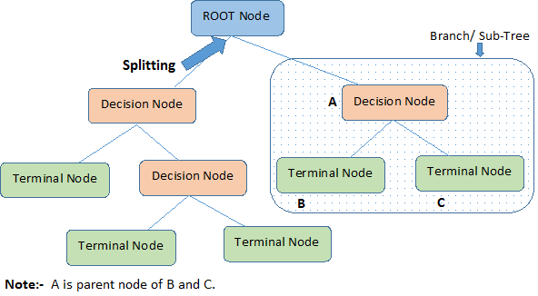](https://www.analyticsvidhya.com/blog/wp-content/uploads/2015/01/Decision_Tree_2.png)

1. **Pruning:**When we remove sub-nodes of a decision node, this process is called pruning. You can say opposite process of splitting.
2. **Branch / Sub-Tree:**A sub section of entire tree is called branch or sub-tree.
3. **Parent and Child Node:**A node, which is divided into sub-nodes is called parent node of sub-nodes where as sub-nodes are the child of parent node.

**Advantages**

1. **Easy to Understand**: Decision tree output is very easy to understand even for people from non-analytical background. It does not require any statistical knowledge to read and interpret them. Its graphical representation is very intuitive and users can easily relate their hypothesis.
2. **Useful in Data exploration:**Decision tree is one of the fastest way to identify most significant variables and relation between two or more variables. With the help of decision trees, we can create new variables / features that has better power to predict target variable. You can refer article ([Trick to enhance power of regression model](https://www.analyticsvidhya.com/blog/2013/10/trick-enhance-power-regression-model-2/)) for one such trick.  It can also be used in data exploration stage. For example, we are working on a problem where we have information available in hundreds of variables, there decision tree will help to identify most significant variable.
3. **Less data cleaning required:**It requires less data cleaning compared to some other modeling techniques. It is not influenced by outliers and missing values to a fair degree.
4. **Data type is not a constraint:**It can handle both numerical and categorical variables.
5. **Non Parametric Method:**Decision tree is considered to be a non-parametric method. This means that decision trees have no assumptions about the space distribution and the classifier structure.

**Disadvantages**

1. **Over fitting:** Over fitting is one of the most practical difficulty for decision tree models because it will create fully grown tree and unseen data may not perform well on this while prediction. This problem gets solved by setting constraints on model parameters and pruning (discussed in detailed below).
2. **Not fit for continuous variables**: While working with continuous numerical variables, decision tree looses information when it categorizes variables in different categories.

 It is known as ‘greedy’ because, the algorithm cares (looks for best variable available) about only the current split, and not about future splits which will lead to a better tree.

the splitting process results in fully grown trees until the stopping criteria is reached. But, the fully grown tree is likely to overfit data, leading to poor accuracy on unseen data. This bring ‘pruning’.

Pruning is one of the technique used tackle overfitting.

## **How does a tree decide where to split?**

The decision of making strategic splits heavily affects a tree’s accuracy. The decision criteria is different for classification and regression trees.Decision trees use multiple algorithms to decide to split a node in two or more sub-nodes. The creation of sub-nodes increases the homogeneity of resultant sub-nodes. In other words, we can say that purity of the node increases with respect to the target variable. Decision tree splits the nodes on all available variables and then selects the split which results in most homogeneous sub-nodes.

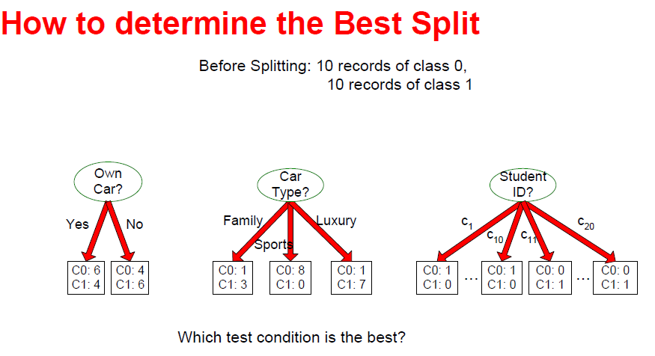

CarType is best split because its giving homogeneous result and low degree of impurity i.e after split we can say whether it will be yes, no or something else based on the majority.

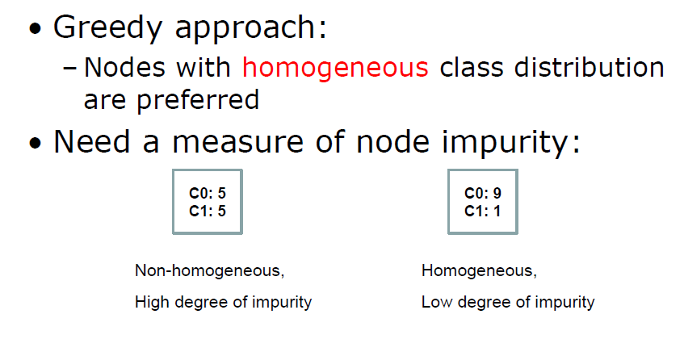The algorithm selection is also based on type of target variables.

### Gini Index

1. It works with categorical target variable such as “Success” or “Failure”.
2. It performs only Binary splits
3. Higher the value of Gini higher the homogeneity.i.e lowest the difference between Gini(Targt) and GiniAvg of other variable(split reduction)
4. CART (Classification and Regression Tree) uses Gini method to create binary splits

.

### Information Gain:

Information gain is biased toward choosing features with a large number of values – The selection of a feature that is non-optimal for predication can result in overfitting.

[Information gain ratio](https://en.wikipedia.org/wiki/Information_gain_ratio) is sometimes used instead. This biases the decision tree against considering attributes with a large number of distinct values. However, attributes with very low information values then appeared to receive an unfair advantage.

* GAINsplit is penalized when large number of small partitions are produced by the split!
* SplitINFO increases when a larger number of small partitions is produced
* Designed to overcome the disadvantage of Information Gain

Look at the image below and think which node can be described easily. I am sure, your answer is C because it requires less information as all values are similar. On the other hand, B requires more information to describe it and A requires the maximum information. In other words, we can say that C is a Pure node, B is less Impure and A is more impure.

[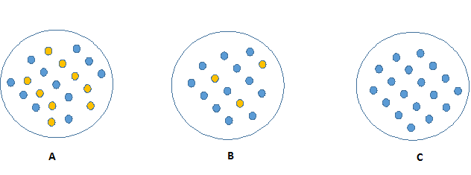](https://www.analyticsvidhya.com/blog/wp-content/uploads/2015/01/Information_Gain_Decision_Tree2.png)

Now, we can build a conclusion that less impure node requires less information to describe it. And, more impure node requires more information. Information theory is a measure to define this degree of disorganization in a system known as Entropy. **If the sample is completely homogeneous, then the entropy is zero and if the sample is an equally divided (50% – 50%), it has entropy of one.**

Entropy can be calculated using formula:-

Here p and q is probability of success and failure respectively in that node. Entropy is also used with categorical target variable.

It chooses the split which has lowest entropy compared to parent node and other splits. The lesser the entropy, the better it is.

i.e lower entropy highest Information Gain because

IG = Entrpy(Target) – Entropy(Other Variable)

Below images are example of how entropy and gini is calculated manually and best split is decided(based on information gain in entropy and lowest gini value in gini index)

Decision Tree to decide whether to Approve Loan ./Not

Features : Age -Young/middle/old

Has Job, Own House, credit Rating

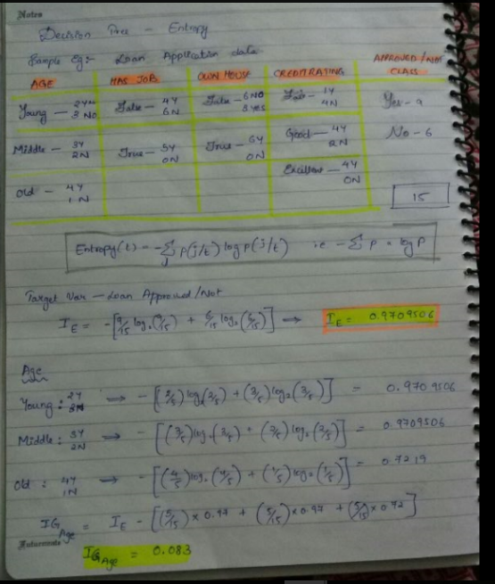

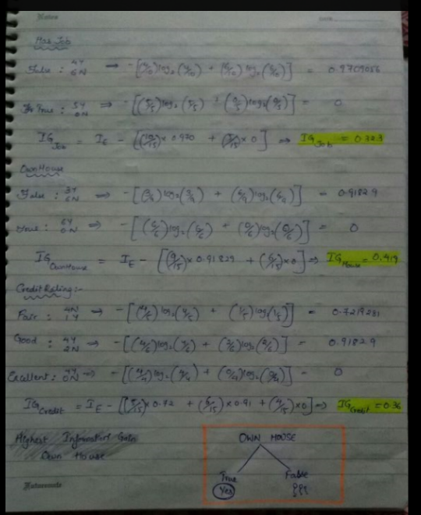

In first step highest Information gain is at own house that is low entropy .SO it would be best split.

For OwnHouse, all True values are yes ,so its an homogenous and pure node.so no further slit will happen at this true node.

Filter the data and remove all records wit true- own house and perform calculation on the rest of the data.

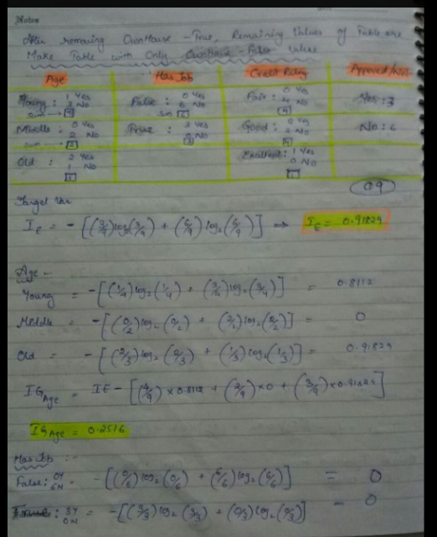

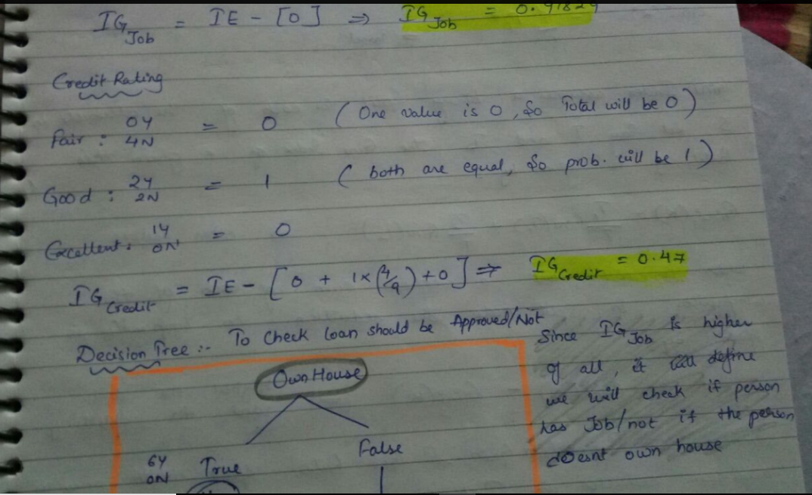

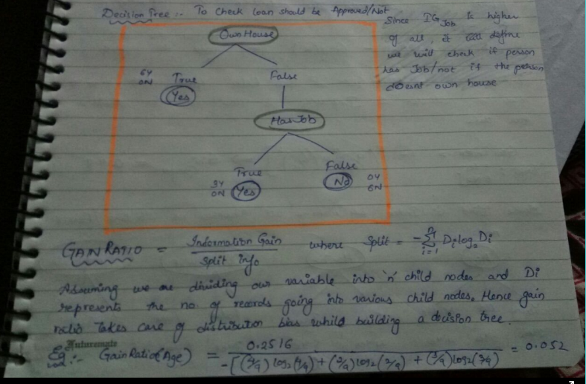

* GAINsplit is penalized when large number of small partitions are produced by the split!
* SplitINFO increases when a larger number of small partitions is produced
* Designed to overcome the disadvantage of Information Gain

**Extranotes:**

Although information gain is usually a good measure for deciding the [relevance](https://en.wikipedia.org/wiki/Relevance) of an attribute, it is not perfect. A notable problem occurs when information gain is applied to attributes that can take on a large number of distinct values. For example, suppose that one is building a decision tree for some data describing the customers of a business. Information gain is often used to decide which of the attributes are the most relevant, so they can be tested near the root of the tree. One of the input attributes might be the customer's credit card number. This attribute has a high mutual information, because it uniquely identifies each customer, but we do *not* want to include it in the decision tree: deciding how to treat a customer based on their credit card number is unlikely to generalize to customers we haven't seen before ([overfitting](https://en.wikipedia.org/wiki/Overfitting)).

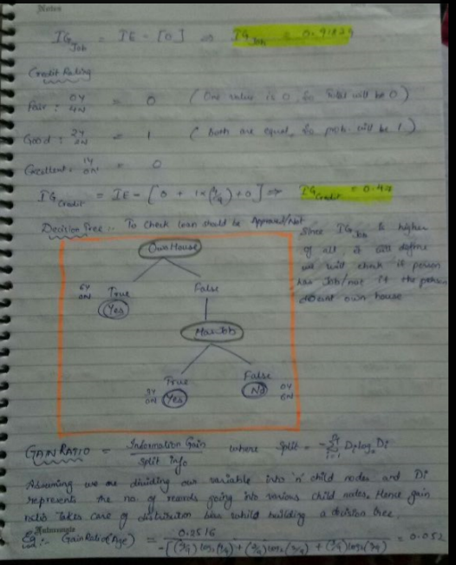

**GINI Index example**

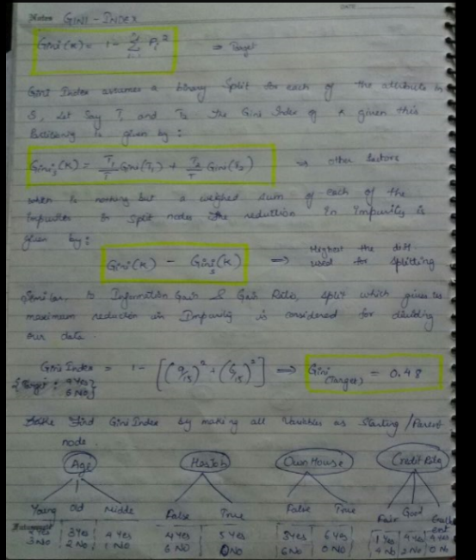

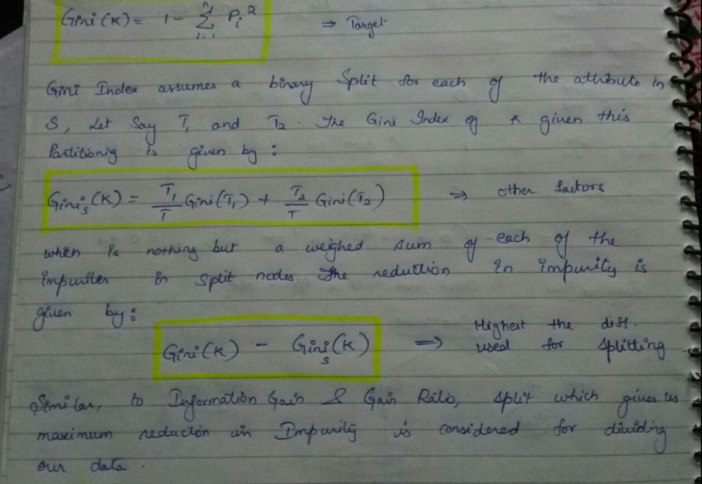

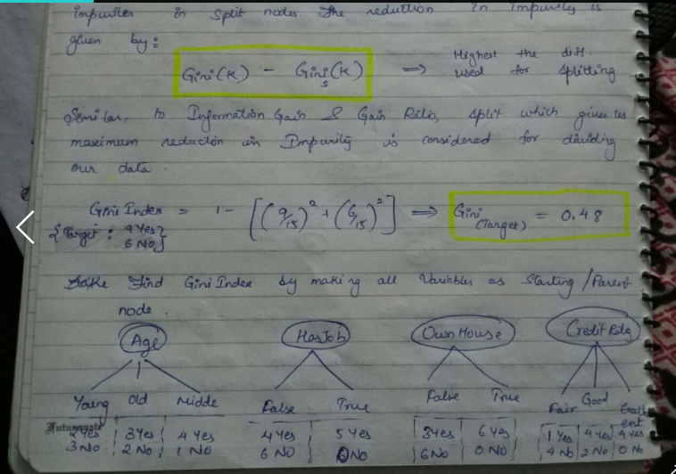

Assume each node as a root node and start calculations

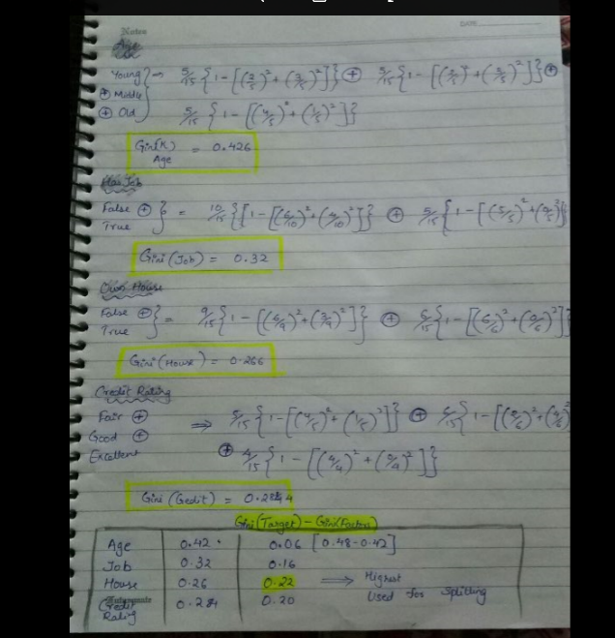

**Reduction in Variance**

Till now, we have discussed the algorithms for categorical target variable. Reduction in variance is an algorithm used for continuous target variables (regression problems). This algorithm uses the standard formula of variance to choose the best split. The split with lower variance is selected as the criteria to split the population:

[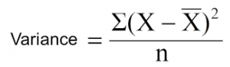](https://www.analyticsvidhya.com/blog/wp-content/uploads/2015/01/Varince.png)

Above X-bar is mean of the values, X is actual and n is number of values.

**Steps to calculate Variance:**

1. Calculate variance for each node.
2. Calculate variance for each split as weighted average of each node variance.

**Example:-** Let’s assign numerical value 1 for play cricket and 0 for not playing cricket. Now follow the steps to identify the right split:

1. Variance for Root node, here mean value is (15*1 + 15*0)/30 = 0.5 and we have 15 one and 15 zero. Now variance would be ((1-0.5)^2+(1-0.5)^2+….15 times+(0-0.5)^2+(0-0.5)^2+…15 times) / 30, this can be written as (15*(1-0.5)^2+15*(0-0.5)^2) / 30 = **0.25**
2. Mean of Female node =  (2*1+8*0)/10=0.2 and Variance = (2*(1-0.2)^2+8*(0-0.2)^2) / 10 = 0.16
3. Mean of Male Node = (13*1+7*0)/20=0.65 and Variance = (13*(1-0.65)^2+7*(0-0.65)^2) / 20 = 0.23
4. Variance for Split Gender = Weighted Variance of Sub-nodes = (10/30)*0.16 + (20/30) *0.23 = **0.21**
5. Mean of Class IX node =  (6*1+8*0)/14=0.43 and Variance = (6*(1-0.43)^2+8*(0-0.43)^2) / 14= 0.24
6. Mean of Class X node =  (9*1+7*0)/16=0.56 and Variance = (9*(1-0.56)^2+7*(0-0.56)^2) / 16 = 0.25
7. Variance for Split Gender = (14/30)*0.24 + (16/30) *0.25 = **0.25**

Above, you can see that Gender split has lower variance compare to parent node, so the split would take place on *Gender* variable.

Until here, we learnt about the basics of decision trees and the decision making process involved to choose the best splits in building a tree model. As I said, decision tree can be applied both on regression and classification problems. Let’s understand these aspects in detail.

## **What are the key parameters of tree modeling and how can we avoid over-fitting in decision trees?**

Overfitting is one of the key challenges faced while modeling decision trees. If there is no limit set of a decision tree, it will give you 100% accuracy on training set because in the worse case it will end up making 1 leaf for each observation. Thus, preventing overfitting is pivotal while modeling a decision tree and it can be done in 2 ways:

1. Setting constraints on tree size
2. Tree pruning

### Setting Constraints on Tree Size

This can be done by using various parameters which are used to define a tree.

[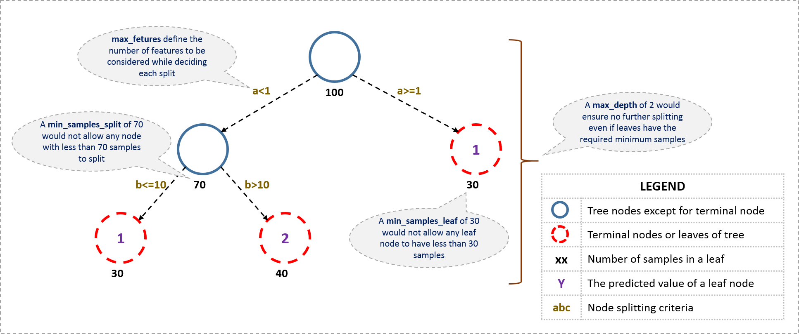](https://www.analyticsvidhya.com/wp-content/uploads/2016/02/tree-infographic.png)

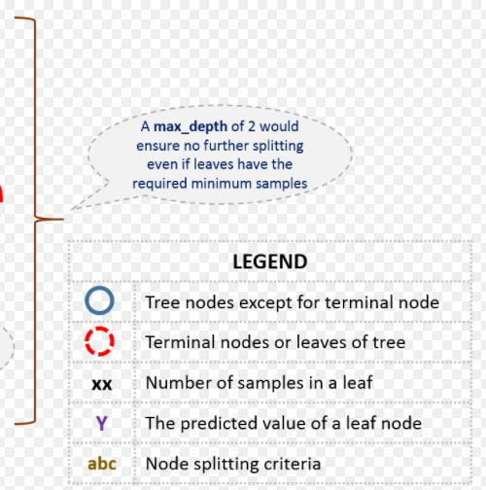

The parameters used for defining a tree min split, max bucket, cp etc.

1. Minimum samples for a node split
2. Minimum samples for a terminal node (leaf)
3. Maximum depth of tree (vertical depth)
4. Maximum number of terminal nodes.
5. Maximum features to consider for split

**Tree Pruning**

the technique of setting constraint is a greedy-approach. In other words, it will check for the best split instantaneously and move forward until one of the specified stopping condition is reached. Let’s consider the following case when you’re driving:

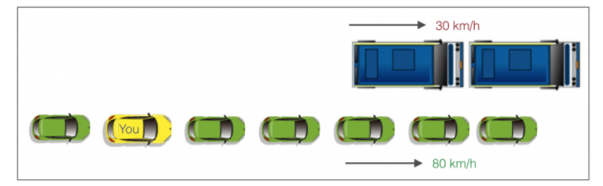There are 2 lanes:

1. A lane with cars moving at 80km/h
2. A lane with trucks moving at 30km/h

At this instant, you are the yellow car and you have 2 choices:

1. Take a left and overtake the other 2 cars quickly
2. Keep moving in the present lane

Lets analyze these choice. In the former choice, you’ll immediately overtake the car ahead and reach behind the truck and start moving at 30 km/h, looking for an opportunity to move back right. All cars originally behind you move ahead in the meanwhile. This would be the optimum choice if your objective is to maximize the distance covered in next say 10 seconds. In the later choice, you sale through at same speed, cross trucks and then overtake maybe depending on situation ahead. Greedy you!

This is exactly the difference between normal decision tree & pruning. A decision tree with constraints won’t see the truck ahead and adopt a greedy approach by taking a left. On the other hand if we use pruning, we in effect look at a few steps ahead and make a choice.

So we know pruning is better. But how to implement it in decision tree? The idea is simple.

1. We first make the decision tree to a large depth.
2. Then we start at the bottom and start removing leaves which are giving us negative returns when compared from the top.
3. Suppose a split is giving us a gain of say -10 (loss of 10) and then the next split on that gives us a gain of 20. A simple decision tree will stop at step 1 but in pruning, we will see that the overall gain is +10 and keep both leaves

Note that sklearn’s decision tree classifier does not currently support pruning. Advanced packages like xgboost have adopted tree pruning in their implementation. But the library rpart in R, provides a function to prune. Good for R users!

Extra notes on pruning

Why is tree pruning useful in Decision trees?

Over-fitting is the phenomenon in which the learning system tightly fits the given training data so much that it would be inaccurate in predicting the outcomes of the untrained data.

In decision trees, over-fitting occurs when the tree is designed so as to perfectly fit all samples in the training data set. Thus it ends up with branches with strict rules of sparse data. Thus this effects the accuracy when predicting samples that are not part of the training set.

One of the methods used to address over-fitting in decision tree is called **pruning**

**Pruning** is a technique in [machine learning](https://en.wikipedia.org/wiki/Machine_learning) that reduces the size of [decision trees](https://en.wikipedia.org/wiki/Decision_tree_learning) by removing sections of the tree that provide little power to classify instances. Pruning reduces the complexity of the final [classifier](https://en.wikipedia.org/wiki/Statistical_classification), and hence improves predictive accuracy by the reduction of [overfitting](https://en.wikipedia.org/wiki/Overfitting).

Tree pruning methods address this problem of overfittingthe data.

Tree pruning attempts to identify and remove such branches, with the goal of improving classification accuracy on unseen data.

Pruned trees

• These tend to be smaller and less complex and, thus, easier to comprehend.

• They are usually faster and better at correctly classifying independent test data than unpruned trees.

• Pruned trees tend to be more compact than their unpruned counterparts

There are two common approaches to tree pruning:

1. prepruning :

♣ In the pre-pruning approach, a tree is “pruned” by halting its construction early (e.g. by deciding not to further split or partition the subset of training tuples at a given node).

♣ When constructing a tree, measures such as statistical significance, information gain, Gini index, and so on can be used to assess the goodness of a split.

♣ If partitioning the tuples at a node would result in a split that falls below a pre specified threshold, then further partitioning of the given subset is halted.

♣ There are difficulties, however, in choosing an appropriate threshold.

♣ High thresholds could result in oversimplified trees, whereas low thresholds could result in very little simplification.

1. post pruning.

♣ The second and more common approach is post pruning, which removes subtrees from a “fully grown” tree.

♣ A subtree at a given node is pruned by removing its branches and replacing it with a leaf.

♣ The leaf is labeled with the most frequent class among the subtree being replaced.

♣ The cost complexity pruning algorithm used in CART is an example of the post pruning approach.

♣ The basic idea is that the simplest solution is preferred.

♣ Unlike cost complexity, pruning does not require an independent set of tuples.

♣ Post pruning leads to a more reliable tree.

## **Are tree based models better than linear models?**

“If I can use logistic regression for classification problems and linear regression for regression problems, why is there a need to use trees”? Many of us have this question. And, this is a valid one too.

Actually, you can use any algorithm. It is dependent on the type of problem you are solving. Let’s look at some key factors which will help you to decide which algorithm to use:

1. If the relationship between dependent & independent variable is well approximated by a linear model, linear regression will outperform tree based model.
2. If there is a high non-linearity & complex relationship between dependent & independent variables, a tree model will outperform a classical regression method.
3. If you need to build a model which is easy to explain to people, a decision tree model will always do better than a linear model. Decision tree models are even simpler to interpret than linear regression!

.





